Group Number (xx) (to be filled by authors)
Date of submission----xx-xx-xx (to be filled by authors)
Title (14, Bold, Times New Roman, Blue)
Authors (12, Times New Roman, For example Y. K. Mishra, R. Adelung)
Affiliation (10, Times New Roman, Italic)
(Received xx-xx-xx; accepted xx-xx-xx; published xx-xx-xx) (to be filled by chairman)
ABSTRACT: (Write here your abstract which was accepted for presentation (12, Times New Roman, Justified). Please remember that if you will copy and paste the abstract than it will go out from top-bottom borders and will disturb the setting. However if you will write it then it will remain in the border) so NO Control C and Control V in this area.
Keywords: Provide relevant keywords ( minimum 3 and max. 5, Times New Roman, 12)

Introduction (12, Times New Roman, Bold)
Text (12, Times, New Roman, Justified) : Please write here some text related to introduction. In this section authors must try to clarify the following questions.
1) What is importance of the field that is why authors have decided to write? (You have make it clear here by your statements that world is going to be under energy crisis in future and therefore we need to discover new resources of energy) (In the text the reference will be superscripted like shown one)
2) How have devices (whatever relevant to you) fabricated/synthesized i.e. past and present history and future demand? What is need in future?
(In this section you can mention how did people synthesized particular devices or nanomaterials or solar cells (whatever relevant to you) etc. and which kinds of problems they faced. How to overcome these problems?)
3) What are prose and cones of different techniques and in what could the intermediate option to gain maximum energy with minimum input ?
Please cite all the references properly
(Remember introduction can be from 800 to 1200 words)

Experimental (12, Times New Roman, Bold)
Text (12, Times, New Roman, Justified)
1) In case of materials synthesis for example graphene, please select the best paper you like from literature and mentioned the experimental details here with proper citations.
2) In case of LED's of USB flash memory please describe how to fabricate it and cite company or paper reference whatever available.
3) For any other kind of stuff please write how to synthesize / fabricate/ harvest etc. with proper citations.
(Remember experimental section can be from 300 to 800 words)

Results & Discussions (12, Times New Roman, Bold)
Text (12, Times, New Roman, Justified)
Here you can select relevant figures from literature related to your field and explain them properly i.e., with proper citations.
In the running text authors have to write
'' Figure 1 (a) shows the microscopy image of graphene nanotubes.........(whatever relevant to you?) OR The scanning electron microscopy images of synthesized graphene nanotubes are shown in figure 1(a).''
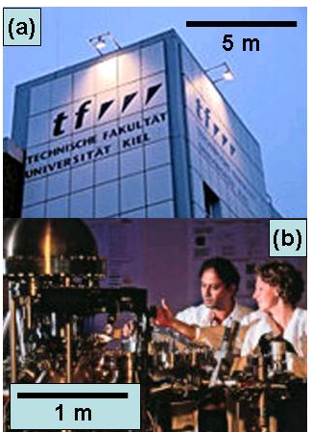
Fig. 1: (a) Camera image of building A of Technical Faculty (CAU-Kiel), (b) XPS setup at Technical Faculty.
Remember this section is supposed to have : min 3 to max 5 figures, you can also use subfigures like (a), (b) etc. and the total text must be within 800 to 1400 words with proper citations in format shown in the reference section)

Conclusion (12, Times New Roman, Bold)
Text (12, Times, New Roman, Justified): Authors must write here what did the learned or understood or discovered from the above paper OR what was the outcome in form of conclusion (max 200 words).

Acknowledgements (12, Times New Roman, Bold)
Text (12, Times, New Roman, Justified): Authors must acknowledge the colleagues or friend who have helped them in anyway to write this article).
Reference

Electronic mail : ykm@tf.uni-kiel.de
B. Gojdka, R. Jahns, K. Meurisch, H. Greve, R. Adelung, E. Quandt, R. Knochel, F. Faupel, Fully integrable magnetic field sensor based on delta-E effect, Appl. Phys. Lett. 99, 223502 (2011).
http://www.tf.uni-kiel.de/

