Optimized Cu contacted Si Nanowire Anodes for Li Ion Batteries Made in a Production Near Process

H. Föll¹⁾, J. Carstensen¹⁾, Emmanuel Ossei-Wusu¹⁾, Ala Cojocaru¹⁾, G. Neumann²⁾

¹⁾Institute for Materials Science, University of Kiel
Kaiserstrasse 2, 24143 Kiel, Germany
²⁾Fraunhofer Institute for Silicon Technology ISIT, Fraunhoferstr. 1, 25524 Itzehoe, Germany

In [1] it was shown that Si nanowires, while doubling their diameter during the intercalation of Li, do not fracture, and that some random arrangement of nanowires, with some diameter distribution centered around 89 nm, can withstand more than 10 charging / discharging cycles without significant loss of capacity. A number of problems of the approach used in [1] with respect to optimum electrode geometries and mass production can be overcome by using macropore etching as the base for making Si nanowire electrodes. First tests of these electrodes in batteries yielded very good results [2]. In the first part of what follows the basic process for producing suitable high-density Si nanowire anodes will be described, in the second part some substantial process improvements concerning quality and in particular manufacturability will be discussed.
The first step for producing dense nanowire arrays consists of etching deep macropores into a Si substrate; the techniques for that have been described in a recent review [3]. Next, careful chemical over-etching enlarges the pore diameter until the pore walls meet, leaving nanowires behind, cf. Fig. 1. The geometry of the nanowires can be adjusted within a wide range by the predefined (simple lithography) geometry of the pores.
Figure 1. a) Schematic top view of macropores (diameter around 2 µm) and their enlargement by chemical etching (dashed lines), b) Formation of nanowires (black) by overlap of the enlarged pores. c) Schematic cross-section with the Cu layer (thickness > 10 µm).
Fig. 2 Specific charge and irreversible losses as function of cycling.
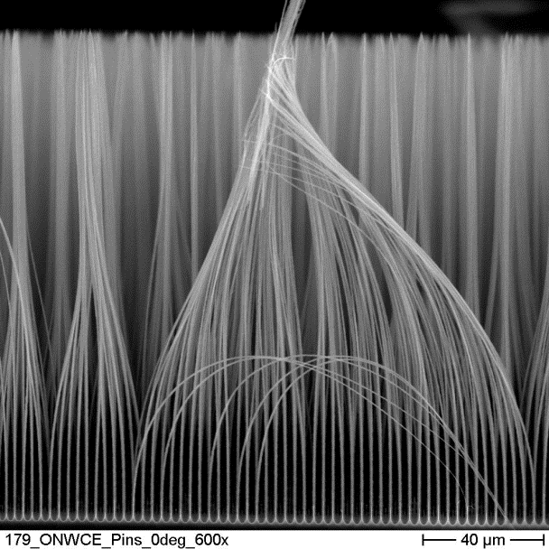
Figure 3. Left: SEM cross-section of “simple” nanowires; showing some “stiction”. Right: Optimized array with 3 stabilizing layers.
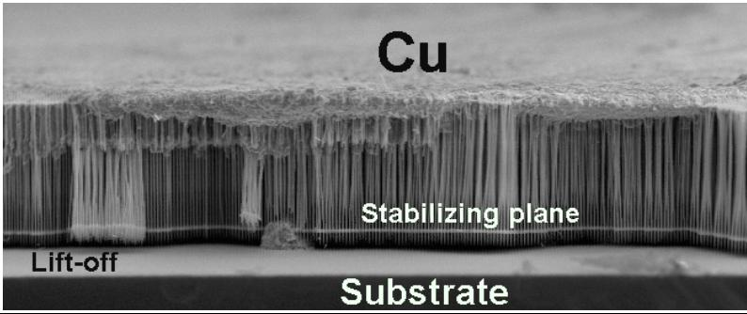
Fig. 4. Nanowires embedded in Cu deposited on top, and partially lifted off from the substrate.
The resulting structure is shown in Fig. 3, left. In order to keep Si from penetrating the Si substrate, a several µm thick Cu layer is now deposited galvanically at the bottom of the nanowires; the resulting anodes have shown superior properties under “bench mark” testing against a standard Li polymer battery, cf. Fig. 2.
The process described so far is cumbersome to some extent. Chemical over-etching, and in particular the galvanic deposition of Cu, are processes with a long duration and a small process window. Moreover, leaks in the Cu layer, allowing small amounts of Li to enter the bulk silicon, compromise the battery quality. A better process involves some sophisticated pore geometry engineering via modulating the pore diameters as a function of depth in order to obtain a certain profile. As a result, the over-etch process becomes much easier and the surface of the nanowires stays stable (avoidance of stiction). It can now be covered with Cu, and since the nanowires have been engineered to be very thin at the bottom, the whole layer of nanowires embedded in Cu can be lifted off with ease; the Si substrate can even be reused (Fig. 4).

References

[1] C.K. Chan, H. Peng, G. Liu, K. McIlwrath, X.F. Zhang, R.A. Huggins, and Y. Cui, Nat. Nanotechnol. 3(1), 31 (2008).
[2] H. Föll, H. Hartz, E.K. Ossei-Wusu, J. Carstensen, and O. Riemenschneider, phys. stat. sol. RRL 4(1), 4 (2010).
[3] H. Föll, M. Leisner, A. Cojocaru, and J. Carstensen, Materials, in print (2010).

